System design questions are common in DevOps Interviews.

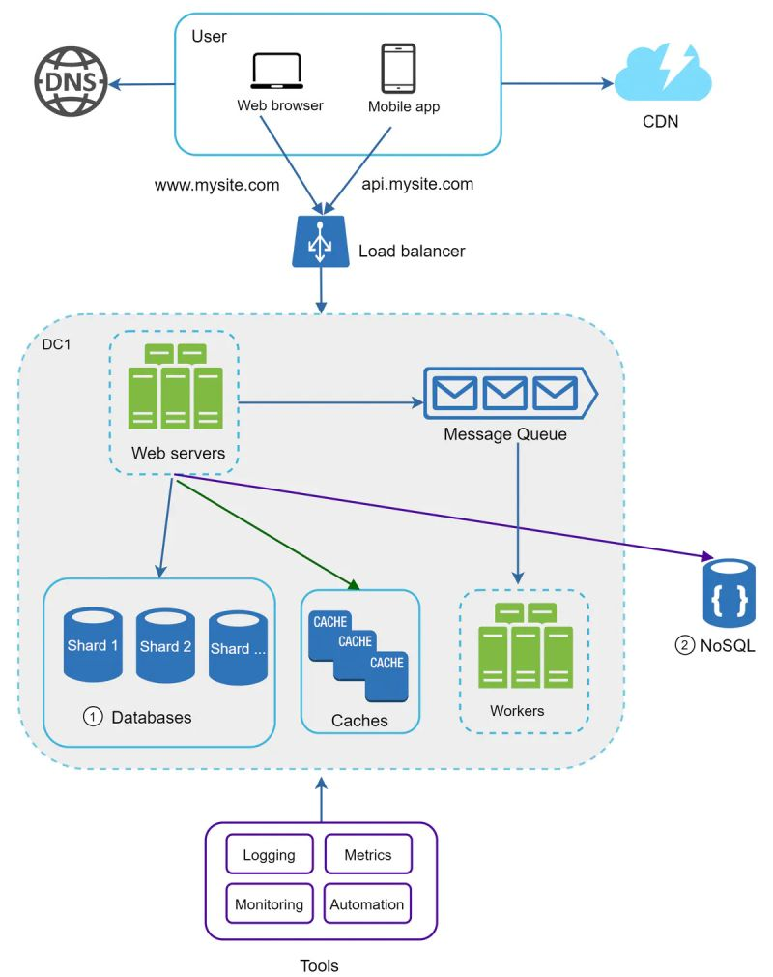

Here is a detailed blog by [Alex Xu](https://www.linkedin.com/in/ACoAAAJcVUEBpKxeVUb94KnEePlKepfIXeP2RM0) on scaling from zero to millions of users.  
  
The blog starts with very basics to important scaling concepts.  
  
Here is what you can learn from the blog,  
  
1. Loadbalancer   
2. Vertical & Horizontal Scaling  
3. Database replication & Scaling  
4. Caching considerations  
5. Content Delivery Network  
6. Stateful architecture & Stateless architecture  
7. Message Queues  
8. Logging, metrics, automation  
  
Also, the reference materials listed have tons of information.  
  
Read the Full Blog: <https://bit.ly/3ztOpSo>  
  
[#devops](https://www.linkedin.com/feed/hashtag/?keywords=devops&highlightedUpdateUrns=urn%3Ali%3Aactivity%3A6940522676532711424) [#devopsengineer](https://www.linkedin.com/feed/hashtag/?keywords=devopsengineer&highlightedUpdateUrns=urn%3Ali%3Aactivity%3A6940522676532711424) [#devopsinterviewquestion](https://www.linkedin.com/feed/hashtag/?keywords=devopsinterviewquestion&highlightedUpdateUrns=urn%3Ali%3Aactivity%3A6940522676532711424) [#SRE](https://www.linkedin.com/feed/hashtag/?keywords=sre&highlightedUpdateUrns=urn%3Ali%3Aactivity%3A6940522676532711424)